**MODULE : 5**

**Stay up to date with AI**

The AI landscape is constantly evolving, presenting both challenges and opportunities for professionals across all industries. Staying informed about the latest advancements in AI can equip you to leverage AI's capabilities, enhance your work, and optimize your skillset. In this reading, you'll learn how to keep your AI knowledge up-to-date as the landscape of AI tools continues to expand over time.  
  
**Search for resources online**

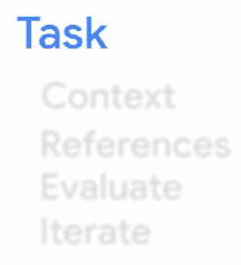The internet contains a vast and ever-expanding supply of information on various topics, AI included. Finding relevant AI-related resources to follow will depend on your industry and the topics you want to learn about. When searching for information, it's important to consider your specific needs so that you can include specific search terms.   
  
  
  
  
 **Use the 5-step prompt framework**